**PROJECT**:NAVEEN ENGINEERING &SPECIALITY

COATING PVT LTD

**BUG ID**: 01

**BUG NAME:** The non responsing of social media icons on homepage

**ASSIGNE:** New

**STATE:** New

**DESCRIPTION:** 1.Open Naveen Engineering &Speciality

Coating Pvt Ltd page

2.In home page on right corner of the screen

3.Please refer the video

**OBSERVATION:** When the icons of social media is clicked it should display the facebook page of Naveen Engineering &Speciality Coating Page should be displayed

**EXPECTATION:** It left remain in the same homepage

**PRIORITY:** Low

**SEVERITY:** Low

**ATTACHMENT:** 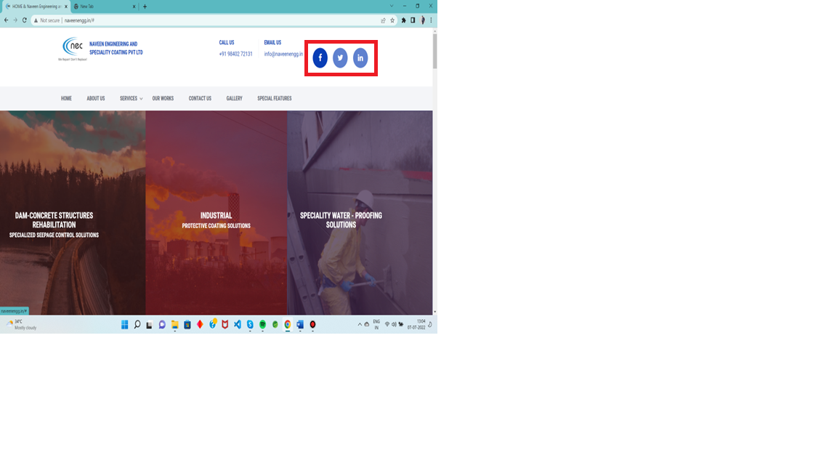

**PROJECT:**NAVEEN ENGINEERING &SPECIALITY

COATING PVT LTD

**BUG ID:** 02

**BUG NAME:** The non responsing of social media icons on

homepage

**ASSIGNE:** New

**STATE:** New

**DESCRIPTION:** 1.Open Naveen Engineering & Speciality

Coating Pvt Ltd

2.In home page left bottom of the screen

3. Please refer the screenshot

**OBSERVATION:** When the social media button is clicked it must navigate to respective official account of the Naveen Engineering And Speciality in respective social media.

**EXPECTATION:** It left remains in the same page when it is clicked

**PRIORITY:** Low

**SEVERITY:** Low

**ATTACHMENT:** 